**CHAPTER IV**

**RESULTS AND DISCUSSIONS**

This chapter evaluates and describes the results and tests conducted by the researchers after the completion of the Face Detection System.

**4.1 System Integration**

A Hardware and Software Integration system required to run the Linux Kernel and its associated Linaro Ubuntu Operating System was successfully designed using Altera Quartus and Altera Qsys. In the **Figure 13** the Qsys environment is shown were the Hardware Integration is done.

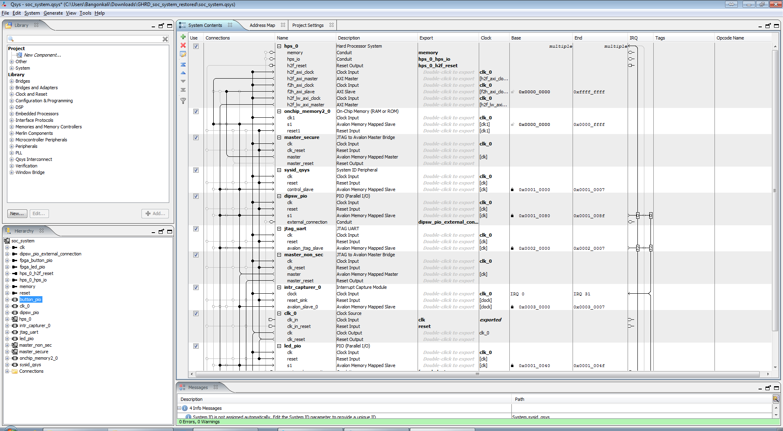

**Figure 13.** Hardware Design using Altera QSys

The output for QSys was successfully compiled by Altera Quartus.

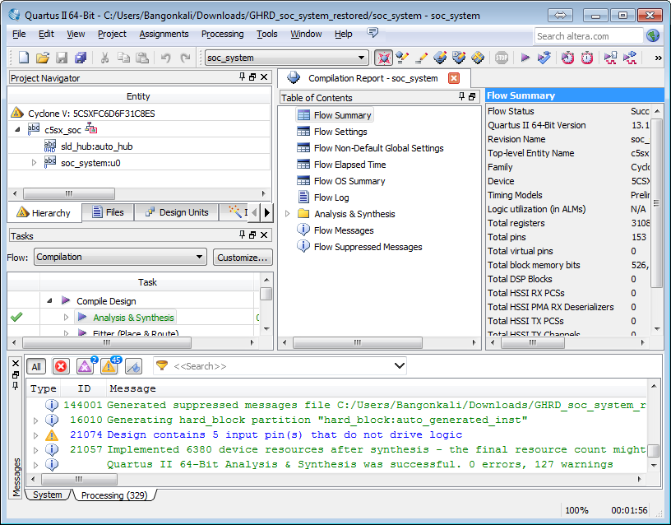

**Figure 14.** Successful compilation of the Boot loader and Hardware Integration System

**4.2 Linux System**

The Linux System was also successfully compiled with the intended modifications using the menuconfig tool of the Linux build environment. Shown in **Figure 15** is the Linux Build Environment toolset.

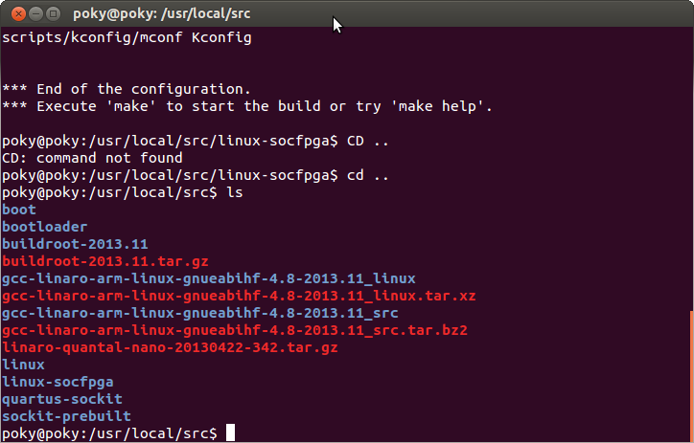

**Figure 15.** Linux Build environment toolset.

**Figure 16** shows the menuconfig tool where the UVC Kernel Module was successfully configured to allow the Linux Kernel to detect Webcam especially the Logitech C525 used in this study.

**4.3 OpenCV Library & Face Detection**

Within the Linux System on SoCKit, the OpenCV System was compiled along with the face detection program. A script was then programmed such that data from the webcam will be sent to the face detection program. In **Figure 17**, the compilation of the face detection program is shown as successful.

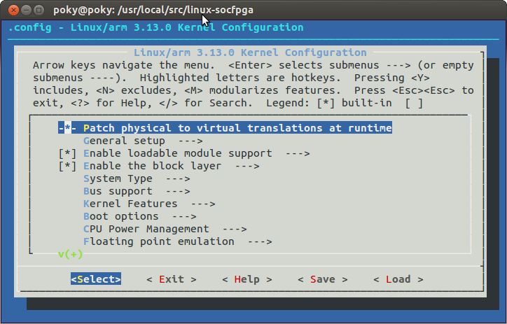

**Figure 16.** Menuconfig tool

**4.4 Performance Comparison**

Using the modified face detect example program and the standard Lena.jpg (See **Appendix K**) Image, the detection time is recorded on **Table 1** and compared to a CISC based system (See **Appendix G** for Specs). For test results of Cyclone V, see **Appendix J**. For the Intel Core i7 Test Results, See **Appendix L**.

**Table 1** Comparrison of CISC based and Cyclon V SoC.

|  |  |  |
| --- | --- | --- |
| Intel Core i7 CISC Based | Cyclone V | % Difference |
| 1687.06 ms | 954.156 ms | 43.44268% |

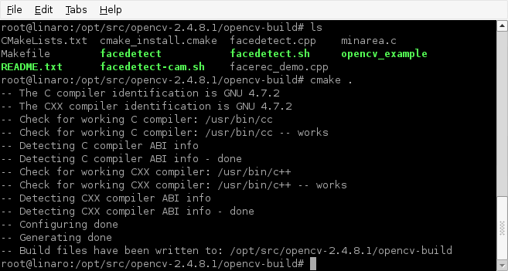

**Figure 17.** Successfully compiled the face detection program

**4.5 System Bugs**

During the development phase despite the researchers careful deliberations in choosing the system components, sources code libraries, and algorithms used it is unavoidable that there may have been system bugs, in fact a few of them show and influence greatly the operation and performance of the face detection system being developed.

**4.6.1 USB UVC Bandwidth Issues with USB OTG**

Though the exact cause of the system can’t be determined there seems to be an issue with bandwidth issues with the USB OTG. This issue becomes manifests itself with the USB based WebCam Logitech C525 not working when the Keyboard and Mouse or other USB peripheral are inserted to the USB Port of an off-the-shelf USB HUB. Only when the USB Webcam is acting alone and on the USB Controller will UVC V4L2 detect the Web Cam.

The temporary solution for this problem was to incorporate the Opensource KVM Emulation Software called Synergy. Essentially the Mouse and Keyboard support is done from another computer. Mouse and Keyboard are both installed on a different computer. Synergy Client listening on the SoCKit board is listening to commands of the Synergy Server running on the computer where the Mouse and Keyboard are. In turn, the Synergy Server is listening to the Mouse and Keyboard Movements of the user and sending it to the client.

Both Synergy Client and Server communicate VIA Ethernet and that is why it is essential among many other reasons that the Development Board must be connected to the network where the Synergy Server is in order to operate it properly.

**4.6.2 USB UVC has some issues FFMPEG**

The researcher also observed that there are some errors in long term operation of the face detection system. This could be in line with the previous case stated on 4.2.1. The Kernel Panic logs are documented on **Appendix H**.